Resilient Bradford is an Adversity, Trauma and Resilience workforce training and development project. A Bradford Trident project, commissioned and funded by Public Health Bradford, we deliver a FREE, CPD accredited programme across Bradford District. We aim to equip organisations and workforces to recognise, address and reduce the potential effects of trauma, and strengthen resilience in individuals and communities.
Adversity, Trauma & Resilience?
Adversity - events, challenges or stressors which significantly increase stress levels and could result in trauma (but don’t always).

Trauma - experienced as physically or emotionally harmful or threatening (overwhelms person’s ability to cope) and has lasting adverse effects on mental, physical, social, emotional and spiritual well-being.
Resilience - the ability to “bounce back” from adversity and/or even having grown, despite it.

Why does this matter?
Studies have shown strong correlations between adversity, trauma and negative outcomes. These could include poor physical and mental health, addiction, risky sexual behaviours, financial difficulties, violent behaviours - all impacting on a person’s life chances and opportunities.
Many people across Bradford’s workforce support individuals and communities who have experienced adversity and trauma. At the same time, staff may be managing the impact of their own experiences. By increasing awareness of Adversity, Trauma and Resilience (ATR) and making small, meaningful changes to organisational practice, employers can create environments that support both staff wellbeing and service delivery, leading to better outcomes for everyone.
For an organisation to be Trauma Informed (TI), it’s vital that ALL members of the team are involved. Our experienced facilitators are on hand to support you to identify the learning needs and practices best suited to progress your organisation’s TI journey.

Our Offer
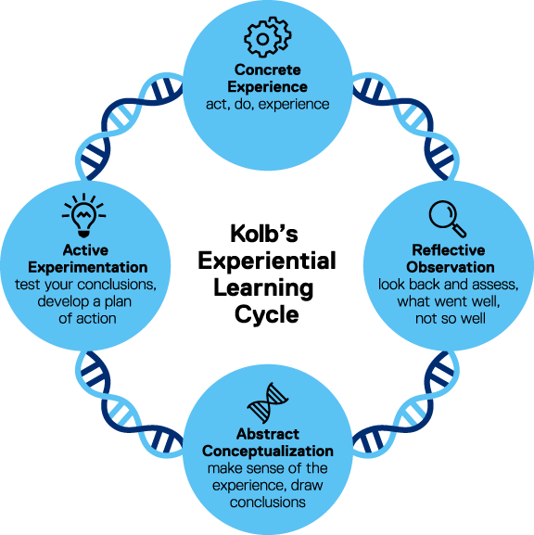
Free CPD Accredited Evidence-Based Training
Tier 1 Trauma Informed Principles
- 3.5 hours CPD accredited session
- Available in person, online and as a bespoke session for your organisation

Tier 2 Trauma Skilled Practice
- 7 hour CPD accredited session
- Available in person, online and as a bespoke session for your organisation

Development of Organisational Trauma Informed Practices
- Resilience workshops
- Organisational Toolkit checklist
- Implementation checklist
- Restorative practices and tools
- Access to the Wellbeing Guide and tools on our website

The Benefits - Outcomes
- A more supported, engaged, reflective workforce
- A supportive, compassionate workplace culture
- Increased staff retention and wellbeing
- Decreased staff sickness and burnout
- Trauma Informed Practice approach across the district
- More resilient clients – reduced complex caseloads

Contact Resilient Bradford
Email Helen@bradfordtrident.co.uk
Telephone 07931 792046
Website: Resilient Bradford

